Fovant Parish Council Defibrillator Risk Assessment

Description of Event
Nerf and Football event to be held at the Sutton Road Playing field on the 8th June 2025

Notes to Participants and Fovant Parish Council Contact Details
The Parish Council has conducted the Risk Assessment (below) and introduced control measures to mitigate the identified risks. The Council will ensure that all volunteers know the risks and understand the control measures before carrying out the activities by issuing a copy of this Risk Assessment.

However, no activity is completely without risk and all participants are reminded they have a responsibility for their own wellbeing and not to place themselves, or others, in harm’s way by taking unnecessary risks.

The contact details for the Council are as follows:

Name  Julie Wallis | Position  Parish Clerk | Contact Details  Tel: 07816511340

Method of Scoring Risk Assessments

The following shows how the risk of each hazard is scored.

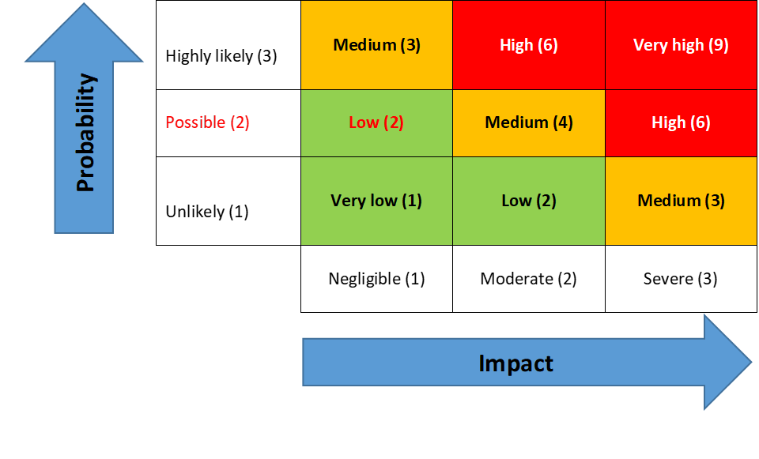 | The Council’s Risk Management Policy is on the website -  Councillors are to review the ‘Controls in Place’ to ensure they exist, they relate to and mitigate the Risk Identified  Risk Factor Impact Action  Red High/very high Immediate notification to the chair and vice chair Identify remedial action for implementation  Amber Medium Immediate notification to the chair and vice chair.  Green Low Notify chair and vice chair

REF | Activity | Risk/Hazard Description | Who is at risk / Risk  Category | Risk Score |  |  |  | EXISTING CONTROLS | FURTHER ACTIONS | RISK OWNER | REVIEW DATES
 |  |  |  | Impact | Likelihood | Risk Rating | Red /  Amber/ Green | Key points | if required Key points |  | LAST | NEXT
DF01 | Monthly defibrillator inspections to take place by Fovant Parish Council | Ensure good working order of all equipment on a monthly basis | ALL | 1 | 1 | 2 | GREEN | - Clerk to undertake monthly checks on village defibrillators for early identification of risk issues | Audit form devised and checks Commenced | CLERK | 07/25 | 04/26
DF02 | Ensure action on defibrillator alerts | Defibrillator may not be ready to be used | All | 2 | 2 | 4 | AMBER | - Clerk to action all alerts within 24 hours or delegate to a councillor if clerk is unavailable | Clerk to respond or delegate task on to a councillor | CLERK | 07/25 | 04/25

