Fovant Annual Parish Meeting , 19th April 2023
Written reports submitted.

- Fovant Parish Council report to Fovant Annual Parish Meeting, 19 April 2023.
Helped by the return to face to face contact with the Wiltshire authorities and the ‘portfolio’ division of tasks among our Parish Councillors, Fovant Parish Council – FPC - has been able to work more effectively this year. The new Parish Clerk Tim Culver-James settled in, and an appraisal system for him has been established. The 2021/22 AGAR was accepted by the External Auditors, and preparations are in hand to appoint an Internal Auditor for FY 2022/2023.
A description of the main Projects in Progress appears on the Parish Council part of the Village Website. In the list of projects the heading ‘Defibrillator’ has been broadened to Health & Wellbeing – and Derryn has opened a folder with that title in the Resources section of the main Website.
So the PC list is :
Website.
Health & Wellbeing.
Highways improvements.
SIDs, metrocounts and the police.
Road drains.
Working group among the (14) Ward parishes.
Interaction with County for road safety and footpath grants.
Emergency equipment and planning.
Updating of footpaths and planters.
I don’t need to replicate the detail here, but there are some highlights. First the village website. Thanks to webmaster Derryn Hinks’ skill and dedication, the website is not only pleasant to view and use but is a comprehensive resource that you know is kept up to date – no mean task for Derryn. Its importance has increased since the demise of the Three Towers Community magazine, following an amazing commitment by Pauline Story for over 20 years. However, sustainability of the Website will have to be addressed just as it became an issue for the 3 Towers. Our Website also contributes to a statutory obligation for Parish Council information to be published. For this reason and the broader value to the community, financial support from taxpayer funds will become increasingly relevant.
Not everyone has digital access or wishes to use it to search for local news. So FPC worked hard this year to see what could be done to produce a monthly printed newssheet to fill the gap left by the 3 -Towers magazine. The Village Buzz magazine now serves 11 villages, and their management team were keen to include news from Fovant. Unfortunately, in December 2022 increased printing costs forced the Village Buzz to cease their printed version and convert to digital only. Derryn Hinks provided several pages of Fovant news into the first few digital months of the Buzz. In parallel, the Parish Council examined the idea of paying to have those few Buzz pages extracted each month and perhaps 50 copies printed, assuming enough people in Fovant would pay a small subscription. The potential costs and complexity killed this idea. The best compromise so far is that Martin Wallis offered to extract 2 pages of news from the Fovant website, each month, and arrange for 20-30 copies to be printed and left for collection in the Village Hall and the Waterside. We would welcome ideas from residents as to how to do more to help households who simply won’t be able to see these newsheets unless they can be delivered to them.
In parallel with all this, we agreed with Derryn that she now cease the considerable effort of sending our news to the digital Buzz – this would only serve as duplication of the Fovant website, which is the one we want outsiders to use!!
Secondly, our focus on Highways matters continues. Data from the three Speed Indicator Devices in the 20 mph limit roads confirm the results from metrocount tubes two years ago - that more than 50% of vehicles exceed the speed value of 25 mph, which is when the police can enforce. Its obvious from the illuminated speed numbers that that some vehicles do slow down but many simply do not. David Horne has extracted the SID speed data into a bar chart format easy for the police to interpret, and we have argued this with the Community Police Team in Warminster that serves our area. Our presentation to a recent Area Board meeting was well received by the police. As a result this police team does seem to be listening, and two officers came to the village recently to discuss our speeding problem. The County is running a pilot study of SID data, and will shortly open that to receive data from SIDs throughout the County. Our main worry is that Fovant data and needs will get buried in the huge mass of County wide information.
There is no doubt that the police will continue to rely heavily on reports of vehicle speeds detected by yellow jacketed teams of Community Speed Watch - a volunteer effort in which Fovant has fallen behind some other local villages. The lack of a CSW puts us at a disadvantage.
Work with the Highways Engineers continues through the Area Board committee system but it was difficult to get used to the changing working practices. We await engineer drawings for a possible buildout footpath on the bend leading into the west side of High Street from the A30. Pedestrian in the Road signs have been agreed for four entrance roads to the village. As County funds can now be sought for footpath repairs, we obtained grants for a contractor to build steps on two of our footpaths. Other footpath work was carried out by the youth charity Seeds for Success. The most difficult project involved steps and a kissing gate on the very steep footpath from East Farm leading up the Down. We procured two more litter bins that the County was discarding; these will go at the northern end of the village.
Determined documented contact with Highways officers in the last two years about persistent blockages and flooding of several of our road drains has paid off, with a comprehensive clean out by teams from the County and the local depot.
The effort put into liaison with the Parish Steward, now taken on by Martin Wallis, is worthwhile because the Steward often provides alerts to the County ’system’ about new issues with drains etc. A word of warning. We have learned that My Wilts complaints about flooding are not prioritised for non-A roads unless property is flooded, and those reports then tend to be dropped off the digital system. The Parish Council therefore remains a last resort for residents not satisfied through a My Wilts report.
After the use of our generators in the aftermath of Storm Eunice, we took advice on how to optimise the Parish’s emergency protocols. Courtesy of the Youth Club Trustees our emergency equipment is now kept in a secure storage area at the Waterside.
Grants made were:
- £800 to the 3 Towers magazine towards costs of publishing Council information.
- £1000 towards the new noticeboards on the Village Hall
- £1000 to construct for emergency equipment store at the Waterside building.
- £400 towards burial ground maintenance
The Parish Clerk acted as ‘banker’ to handle the Wiltshire Council grant obtained by Diana Rae to cover warm space/foodbank costs, and the Parish Council contributed a further £218. Reflecting the increased public debate about health matters, the Council will pay for any further awareness raising courses on first aid and defibrillator use.
At the invitation of Christine Brown (Wiltshire Council Estate and Development Team), FPC set up a subcommittee to work with her on options for the redevelopment of the Clays Orchard site.
FPC played a minor role in a group of seven villages that raised concerns about a proposed development at Tisbury Station – a large housing development, a care home, and narrowing of the road bridge to a single archway that would need to be traffic light controlled -- all inconsistent with the Tisbury Neighbourhood Plan. The decision from an Appeal is awaited.
The Electoral Review Committee had not yet dealt with a 2019 request for the number of Councillors to be reduced. FPC reviewed this and decided to keep to the present maximum number of nine councillors.
- County Councillor, Mr Nabil Najjar
It’s now been almost two years since you elected me as the Councillor for Fovant and Chalke Valley, and I wanted to let you know a bit about what I’ve been doing to try and make the area and even better place to live, work, and raise a family.
When I campaigned to be your Wiltshire Councillor back in 2021, I promised that I would tackle speeding and road safety, deliver investment into the Chalke Valley, and support our communities. Here’s a snapshot of what I’ve done so far to deliver on those promises:
Tackling speeding and road safety  This has been a priority for me, and I have secured Wiltshire Council funding to buy and install new speed indicator devices in Fovant, Barford St Martin and Berwick St John.  We have helped purchase new road signage in Sutton Mandeville and Berwick St John warning HGVs that the roads are unsuitable.  As Chairman of the South West Wiltshire Area Board, I have continued to ensure we focus on road safety.  Last year, I set up the Chalke Valley Speed Working Group to try and address these issues at a wider level, and we have engaged with Wiltshire Council and the Office of the Police and Crime Commissioner to see what more we can do. | Investing in the Chalke Valley  Since I was elected, I have done everything I can to get money out of County Hall, and into our communities.  We secured over £8,000 to support the community in Barford St Martin in building a new playground, £5,000 for a playground in Broad Chalke, just under £10,000 for the Chalke Valley Sports Centre, and £4,000 for Fovant Youth Club.  We gained Wiltshire Council Funding for Village Hall improvements in Burcombe and Berwick St John.  We have also delivered for pedestrian gates, street-scene improvements, and footpath improvements and more in Fovant, Sutton Mandeville, Compton Chamberlayne, and Swallowcliffe.
Supporting our communities and partners  I have worked hard to ensure our Parish Councils receive the support they need from Wiltshire Council.  We have managed to raise funds to support community groups across the area, and I campaigned to ensure Wiltshire Council continued to provide funding for the Cranborne Chase AONB.  We were able to fundraise for the establishment of warm spaces in Fovant this winter, to support Summer Concert in Sutton Mandeville, the funding and installation of the Community Cinema in Broad Chalke, and the Alabare Development Centre in Barford.  I worked with my Parishes to secure Wiltshire Council investment in the Chalke Valley Fete and Produce Show, to help the event grow year on year. | Supporting residents across the area  Much of my work centres on responding to, and advocating for, the needs of residents in my division.  I attend as many Parish Council meetings as I can, across all fifteen Parishes in my division, and I am always available if people have questions, or need help and support.  I work with my residents and communities on issues ranging from planning applications, to highways improvement, and all points in between.  A particular highlight for me was working with residents of Heath Farm Park, and Ebbesbourne Wake, supporting them in objecting to contentious and challenging planning applications which would affect their quality of life.

- Spring Orchard surgery April 2023 Dr Lindsay Kinlin
Highlights
- Activity rates continue to be high compared to pre-COVID levels
- Cancer investigation conversion rates need to improve
- Continuity of GP care is excellent
- Change to clinics on Fridays
- Monthly clinical topic sessions at Fovant village hall
Data
- Practice profile is stable apart from increase in patients aged over 90 (from 22 to 33 patients) Total list size is 1515, 86 new patients. 11 patients died, 5 of these at home. 15 new babies (same as in 2018)
- 50% of patients are on a repeat prescription (typical for UK)
- Long-term condition prevalence:
  - 20% of the total patient list have hypertension (305 patients)
  - Other cardiovascular conditions – 73 patients with ischaemic heart disease, 80 have renal impairment, 78 atrial fibrillation, 13 peripheral vascular disease, 48 previous stroke
  - 91 diabetics (173 have pre-diabetes)
  - 11 patients with severe and enduring mental health problems (e.g. schizophrenia), 15 have dementia. Rates of depression are higher than national prevalence (8% vs 4%)
- Cancer conversion rates need improving (11% against a target of 3%) 68 fast track cancer referrals led to 8 new cancer diagnoses. Total of 15 new cases of cancer in the 2022, 115 patients living with previous cancer diagnosis.
- COVID diagnoses increased since 2021 (from 119 to 219) but no hospitalisations or deaths, long COVID referrals low (5)
- Activity continues to be high – 5754 GP consultations at the surgery, 167 home visits, 2907 nurse appointments, 502 flu jabs.
- 34 prolific attenders (more than 15 appointments in the last 6 months) = minimum of 510 appointments for just these 34 patients.
- Continuity of GP care is excellent (94% LK or FvD rather than a locum)
- Drop-in clinics reintroduced on Fridays, hybrid system for the rest of the week
- Revamping waiting room
- Monthly clinical topic sessions at Fovant Youth Club / village hall going well.

- Dinton CofE VC Primary School. Mr Andrew Howard
As usual, life at the village Primary School has been really busy. We have 82 pupils on roll with small classes of between 13 and 26. One quarter of the children who attend the school reside in Fovant. We currently have a small number of places in other year groups.
This year we have appointed a new specialist music teacher, Mrs Askew and she has been inspiring the children to do some super singing including Gaudette, which we sang on local radio and to Dinton village coffee group. We have a large number of children learning piano, violin, trumpet and trombone. We are just starting to rehearse for our end of year musical, The Lion King.
We have undertaken a number of exciting residential trips recently with children spending 3 days in London, going to the Tower of London, Westminster Abbey, the theatre and meeting our MP at parliament. This cultural trip contrasts with our other residential trips to Cranborne Ancient Technology Centre and Portland Outdoor Education Centre where children learn to kayak and climb. Children have also been out and about exploring the local area, visiting Fovant badges as part of a project on Remembrance, where they designed their own walk around the area.
On the sporting front, older pupils enjoyed the indoor cricket festival at Five Rivers with the Y5/6 team winning convincingly and Y3/4 coming a close second. Children and a few parents are training hard for the Salisbury mini-marathon in May to see if they can be even more successful than last year. The youngest children had an enjoyable day out as part of their ‘ticket to ride’ project travelling to Salisbury by bus, then to Tisbury by train and then coming back to school by bus. Quite an adventure for our 4/5-year olds. As well as visiting other places, we had some visitors from Longleat come to see us. Children who wanted to do so handled everything from millipedes to a python. Children in Y1/2 also had an ‘eggciting’ watching chicks hatch and grow. The chicks have been safely rehomed on a local farm. You may have seen our oldest pupils learning to cycle as part of the bikeability scheme. We are very proud that they all successfully passed and know how to safely cycle around the village.
The School is well supported by the Friends Association. They have been really busy this term hosting a super film night, Christmas fayre and disco. We have raised sufficient funds to buy our own fire-pit cabin to allow us to improve our Forest School Provision and teach cooking outside. It looks absolutely amazing. We have also installed a new soft surface playground installed in October making our grounds even better. Most of the children have already enjoyed story time in the log cabin and we look forward to using it lots as the years go on.
The school emblem is an owl to demonstrate the school value of wisdom. As the collective noun for owls is a parliament we have a school parliament to give pupils the opportunity to share ideas and feedback on how to improve the school and community. One initiative this year has been working with the surgery in Fovant to improve the waiting area for young people.
Looking forward, the school has made the decision to leave Local Authority control and join a multi-academy trust. After much consideration, the governors have decided to join the Acorn Education Trust in Warminster which is responsible for 12 other Primary Schools as well as 3 Secondary Schools. This will allow us to work more collaboratively with similar schools as well as allowing us to be efficient. It is important to say that key things like uniform, our links to the church and Secondary Schools will not change in any way. There will be a consultation meeting for any member of the local community that wants to attend in the summer term.
Andrew Howard – Head teacher
- Fovant Village Website Ms Derryn Hinks
The Fovant village website has been in existence for one year and 5 months, successfully providing relevant, up to date and useful information on events, groups, resources and facilities in the village in an agile format. Local groups send new information through regularly for updating by the webmaster and any changes requested are made promptly. This means the website is responsive to local needs & proactive in promoting events & items of interest. An example of this was a new page of information & links for the ‘Cost of Living,’ also the ‘Jubilee Celebrations’ & ‘Neighbourhood Warmth’ and following the recent Defibrillator training, a new ‘Health & Well Being’ Resource page.
In March 2023 alone the website had 319 unique site visits which means 319 different people not 10 people visiting it 30 times for example. This figure is 66% better than other comparable websites. In the last year, the site has attracted 2,640 unique site visits which is impressive considering there are approximately 734 people in the total population of Fovant, meaning we are clearly appealing to a wider audience. This is 92% better than other comparable websites. During the course of last year, the website experienced 38 unique visits a day on average, although it has been as high as 149, which demonstrates that it is fulfilling its function of providing useful information to the residents of the village. More pertinently, since the last publication of the ‘Three Towers’ magazine in December, there has been a 100% increase in traffic to the site with an average of 78 unique site visits per day in the months of January to March 2023. This demonstrates a willingness to engage with digital information in the village.
The most visited page is the Homepage and the average time spent here is 5.37 mins which is 1 minute longer than in the report last year. The homepage is popular because it contains details of upcoming events and the village calendar. 48% of users choose their mobile phone to access the website; 45% use their desktop pc and 7% their tablet which is a very similar profile to last year.
The annual running costs of the website are £246.733; a £74 increase from last year. This cost is met by the Fovant Parish Council although all the design, development and maintenance of the site is completed free of charge.
Of further note:-
External agencies and organisations are increasingly finding our website and requesting to be linked to it. The last month would provide a good example with the Marketing & Advertising Managers of ‘Experience Salisbury’, ‘Trainline’ & a variety of local charities & Arts groups linking up, and even BBC journalists have used it to source their research into our local history in connection with one of their programmes.
The Business Directory page continues to grow with local businesses requesting to be added, although there are no paid advertisements or booking facilities.
The contact email address linked to the website is used daily by individuals & organisations for queries, listings & bookings & information, which the webmaster responds to.
The existence of the website has also proved significant in adding value and providing crucial evidence for successful grant applications for the village; Wiltshire Community Fund and National Lottery.
Derryn Hinks – Webmaster of www.fovantvillage.com

6. FOVANT YOUTH CLUB. Mr Clive Roberts
Another busy year for the Youth Club and this report looks at four areas: Events Major Expenditure Regular Hirings Clubs Events The major events of the last 12 months for us was an open day in July and the Christmas Fair, organised by Julie, with support from committee members. Both were well attended and successful and in the Christmas Fair, we had a number of stalls, selling various goods in the Village Hall and a Children’s’ party with Father Christmas in the youth club. Major Expenditure We continue to invest in our building and it is now at a very good standard. We were able to replace the flat roof, using our own funds and also supplement the new heating system so it is now very warm even through the winter. Finally, mainly funded through a National Lottery grant, we were able to install a new outdoor surface, to improve access. Regular Hirings Unfortunately we lost two of our regular hirings S4S and Home Ed and the warm space initiative which we shared with the village hall, did not attract anyone. However we retain some regular bookings and also had some one-off hirings. Clubs Turning to the clubs that we run ourselves, the Toddlers and Juniors remain successful and although we ventured to run a seniors night, this proved not to be viable over the winter and we stopped it in February. However for the summer we intend to open Juniors Plus; more news about this will be on the Fovant website in due course. For those who like numbers, the data is as follows: Seniors 11 years to 16 years 09/09/22 - 03/02/2023 17 sessions total of 142 young people Juniors 5 years to 11 years 06/04/2022 - 29/03/2023 317 children with 154 adults Mainly families with multiple children Toddlers 0 years to 5 years 06/04/2022 - 29/03/2023 250 children with 245 adults Mainly 1:1 mother and baby but also some professional nannies Overall many families are weekly regulars with others coming regularly but not every week. Mainly Fovant families but some Dinton. Finally, I thank all the Committee members and our volunteers who have helped over the past year, but as always we are always looking for more people to help. On that note, the next AGM is on Monday 5 June at 7pm. All are welcome to attend.

7. The Fovant Network. Mr Jeremy Hinks
The Fovant Network came into being in early 2021. It’s origins come from discussions within the Fovant Community Support Group (FCSG) team. Within this group there was an interest in ensuring there was a legacy benefit from the village support network created by FCSG that would survive beyond the acute stage of the C-19 pandemic. The first meeting of The Fovant Network (January 2021) established membership and purpose. The membership currently includes nominated representatives from the Fovant Badges Society, Fovant Village Hall, Spring Orchard Surgery, Fovant Parish Council, Fovant Community Support Group, The Waterside Youth Club, St George’s Church, Fovant Relief in Need, and FILGroup. Other village-based groups are welcome to connect into The Fovant Network by providing a nominee to attend the occasional meetings. The network is supported by Dr Jeremy Hinks who acts as convener and facilitator for the group. The purpose was agreed as ‘to share knowledge, experience and resources between village groups, supporting their ability to provide facilities and activities for all age groups. In doing so to ensure that Fovant is a village having something to offer everyone who lives here.’ The Fovant Network exists to ensure that the collective wisdom and experience across the village can be bought to bear on project work of interest to villagers. It does not meet for the sake of it. Instead, it is available to convene should there be a project that would benefit from the input from a group that is stronger than the sum of its parts. It has no budget or decision making authority yet it can quickly identify a consensus (or the lack of one) in support of projects intended to offer something to enhance village life. In doing so The Fovant Network empowers those groups within the village who have both budget and decision making powers to move to action. The Fovant Network has been instrumental in setting the wheels in motion for a number of significant village activities over the last couple of years. Once in motion those wheels are driven by various of the village groups, or individuals connected to them. Most recently Fovant Network convened to discuss approaches to support people struggling under economic pressures. This led to warm space projects and food bank provision which were promoted along with other activities in a village wide mailing. In the past Fovant network was also influential in establishing the Fovant Village website (www.fovantvillage.com) and in the early stages of coordination of the many activities held to celebrate the Platinum Jubilee in 2022. JDH April 2023 .
8. Fovant Community Support Group. Ms Diana Rae
As Autumn 2022 approached, we all became increasingly aware of the extra financial pressure households could find themselves under as fuel prices rose dramatically with no sign of this improving or abating.
In response to this pending situation, the FCSG collaborated alongside the Waterside Youth Club, The Fovant Chapel and the Village Hall to work together to offer warm spaces in a comfortable, non-judgemental environment.
The FCSG were successful in applying for funds totalling £500 from the Wiltshire Area Board in December 2022, which, alongside donations kindly received from the Parish Council and St George’s Church, totalled a sum of just over £800 - the amount calculated to cover a period of 4 months from November 2022.
The Fovant Chapel quickly became the location for a satellite Food Bank organised under the umbrella of the Trussell Trust.
The Waterside and the Village Hall organised their own sessions and rota of volunteers.
This money was directed to help buy soup, rolls, biscuits, coffee, tea, blankets and hot water bottles and a leaflet was designed and printed and delivered to every house in the Village. The money donated will also be directed to help with increased heating bills sustained by the Waterside and the Chapel throughout this period which started in early November 2022.
Diana Rae
Fovant Community Support Group
9. Fovant Village Hall. Ms Celia Haselgrove
This has been a year of mixed fortunes for the Village hall.
It has been much improved with the installation of a new speaker system, hearing loop and automatic projector screen. The committee are so grateful to Derryn Hinks for her determination to have this installed despite the difficulties with obtaining all the elements and then finding a date for the actual installation.
Linda Bailey our buildings officer has overseen the installation of a new water heater, a kitchen plinth heater and an automatic dehumidifier for the kitchen. Tap class, seated exercise class, orchestra, Filgroup, Open Door and Saturday Breakfast remain regular activities, Moon’s Meditation retreat continues to have a Meditation day with lunch once a month and the writing group has restarted Parties are booked regularly and the Harvest Lunch again took place in the hall.
The installation of WiFi has been of huge benefit and especially to the efficient running of the 2 flu vaccination clinics run by Spring Orchard. On the downside we lost two of our regular hirings. Lisa Rich found a property to rent for her Pilates and the Valley Choir never really recovered after Covid.
Events run by the committee this year have been the ever popular quiz nights one in October and another this April, the Christmas Ploughman’s Lunch, a cheese and wine evening and after repeated attempts we have finally been able to book our usual arts event for this Autumn. The village hall was open for cream teas for the late Queen’s Jubilee and also hosted a display of Historic Fovant.
With the cost of living problems the committee made the decision to open the hall as a warm space during the winter months and to provide hot drinks and soup. This had a limited up-take.
In January an unfortunate incident caused by vandals saw a car unattended run down the hill from Spring Orchard and demolishing part of the fence. The committee were extremely grateful to Martin Wallis for arranging the reconstruction of the fence.
We are still seeking a treasurer and anyone interested in this position should contact me.
Celia Haselgrove. celiahaselgrove@btinternet.com
10. FOVANT SATELITTE FOOD BANK. Ms Julie Wallis
Fovant satellite food bank was explored as a potential to support our local community at a Fovant network meeting in October 2022, the meeting was convened to discuss possible collaborative working and ways in which to support Fovant residents who may be affected by the current economic crisis.
Following discussions with Salisbury Foodbank and visits to other villages who have set up similar projects, two residents formally became Salisbury food bank volunteers and set up the food bank within the Chapel on the High Street. The food boxes are supplied by Salisbury food bank and are nutritionally checked upon packing, we can also provide fruit and vegetable deliveries direct to homes as well as food parcels (courtesy of Central fruits). We have in stock, a range of personal care toiletries, cleaning products, nappies as well as cat and dog food. As part of the support we give we also have a rail of warm coats donated to us by local residents and hot water bottles and blankets kindly funded with monies gained by the Fovant Network.
The venue was chosen as it gives a discreet entrance and a warm inviting space for those attending, hopefully taking away some of the concerns first time visitors may have, all those attending are welcomed with tea and biscuits whilst their food concerns are met, if they have a foodbank voucher this will be honoured, if they have no voucher but on discussion they have food needs, we are able to issue vouchers ourselves and give out food boxes. before potentially supporting the individual by sign posting onto other providers who may be able to support them e.g housing, fuel costs, CAB, loneliness, children’s services.
Since the 29 th November 2022 we have been issued with 19 food bank vouchers and fulfilled 13:
G.P’s surgery – 4
Centre for sustainable energy – 1
Wiltshire council (housing) – 8
Childrens centre – 1
Community first – 1
Red Jacket – 2
Job centre plus -1
We have also had a number of visitors to the foodbank who are seeking signposting on or simply a cup of tea and a chat.
Our reach has been Fovant, Dinton, Sixpenny Handley, BowerChalke and Tisbury.
Moving forward we will be reviewing the voucher initiation dates to ascertain if changes are needed to our opening hours.
Julie Wallis
julie@wallisfam.co.uk
07816511340
11. FILGroup 2022-23
Once again this has been a very busy year for the FILGroup.
The membership has grown to over 20 with everyone being treated to a wide variety of events.
The group has had several well received speakers with Elizabeth Green talking on her charity cycle ride to Sri Lanka, Karen Lockyer demonstrating the art of make-up, local reflexologist Pip Zingg who gave a real insight into her alternative medicine practice with many members taking advantage of a special introductory session .In February we were all enthralled by Professor Nigel North’s talk on the very real subject of PTSD.
2 visits took place during the year-:In October 11 members visited Waitrose for tea and cakes and a ‘behind the scenes’ tour of the store which proved to be surprisingly informative. On a sunny day in June a similar number went on a Jane Austen day to Chawton.
Two occasions in the year saw members ‘hands on’ first at a jewellery workshop & also decorating chocolate eggs for Easter - with all the creations proudly taken home at the end of the afternoon.
David & Celia Haselgrove were very welcoming with a tour of their beautiful garden on a lovely sunny evening in May followed by Pimms in the sunshine.
A group of 28 (members & partners included) were treated to a wonderful dinner just before Christmas in The Greater Good ably catered for by Alex and his staff.
Future events include a talk on Dorset Buttons, an outing in June-this year to The Silk Farm at Whitchurch & of course the annual Garden Party in July which was sadly cancelled last year due to Covid
We welcome all ladies and on many occasions partners & family as well to the meetings which now take place on the 2nd Thursday of each month at 2.30 pm.
Please contact e-mail: filgroup15@gmail.com
12. Fovant History Interest Group. Ms Mary Kirman
The Fovant History Interest Group was established around 20 years ago with the following purposes:
• To do further research on the history of Fovant from external sources as well as from local
residents and ex-residents.
• To index the historical records and images of Fovant and make them available via a website and publications.
• To interest the residents of Fovant in the history of their village by organising or being involved in events.
Membership has always been open to anyone in any location wishing to learn more about any aspect of the village’s history or to provide any information about the same.
Changes in Membership
Mary Kirman, who became a member of the group in 2001, remains in the role of Chairperson that she took over in 2021, although full-time work commitments and family issues throughout 2022 inevitably meant that her activity and therefore that of the group was more limited than would otherwise have been the case.
Nicola Matthews, who was also an early member of FHIG, remains in the role of Treasurer that she took over in 2021.
Rupert Williamson remains in charge of the website www.fovanthistory.org , which he also took over in 2021, and receives any emails sent to the group via the website, dealing with them as needed.
One of the two new members who joined the group last year has moved away from the village, but the other new member Sue Kent has taken over from Liz Harden the changing of the display boards in the pub and shop. This is along with Derryn Hinks who is very interested in the group, but has other time commitments owing to her management of the www.fovantvillage.com website, which in turn contains information about the history of the village.
Liz Harden remains actively involved in the group and we regularly draw on her extensive knowledge and large collection of documents and photographs as a consultant. She is also always happy to arrange for anyone interested to come and view her collection for items of interest to them.
Activity of the group in the past year has included:
• The exhibition held in the Village Hall on Saturday 4th June 2022 as part of the village’s
celebrations for Queen Elizabeth II’s Platinum Jubilee which proved to be a great success.
The exhibition was open from 11 am to 4 pm with refreshments available to purchase courtesy of volunteers made up of friends and family of the group’s members.
Items displayed included the tablecloth embroidered with the names of the then members of the Parish Council made for Queen Elizabeth II’s coronation, files of newspaper cuttings about people and events in the village from Margaret McKenzie’s collection, and some of Roy Nuttall’s collection of World War One artefacts and pictures that used to be displayed in The Pembroke Arms for many years.
The display boards, put together by Rupert Williamson, featured an outline of Fovant’s history, Fovant houses, Fovant Coronation and Jubilee events, other Fovant social events such as fetes, fun days and scarecrow competitions, the development of the Poppy badge in 2016 and the Fovant Military Railway. Entry was free but donations were gratefully received, and these plus the sales of both the refreshments and the book Fovant – Pages from our History, written by the members and published in 2005, added to the group’s limited funds which are mainly spent on maintaining the hosting of the website.
The exhibition received a steady flow of visitors made up of both relative newcomers to the village and some very longstanding residents. It was particularly lovely to see three 90 year old ladies get together again to share their joint memories of being young wives and mothers in Fovant in the 1950’s and 1960’s.
• As mentioned earlier, member Sue Kent has taken over with Derryn Hinks the rotation of the 21 display boards created by Liz Harden, and each featuring a different aspect of Fovant’s history. These boards used to move between the pub, the shop and the Village Hall but since the refurbishment of the hall this venue has not been used as it is not no longer possible for the boards to be displayed in the main room. However, Mary Kirman and Liz Harden were consulted by Dr Kinlin on the refurbishment of Spring Orchard Surgery’s waiting room post-Covid, and a board will now be displayed there.
• After giving up the editorship of the Three Towers magazine, leading to it ceasing publication, Pauline Story donated her collection of all past editions of the magazine to the group, going back to its first incarnation as a couple of sheets of A4 paper stapled together.
• The group was contacted recently by a researcher from the BBC1 programme Antiques Road Trip, as suggested by the Fovant Badges Society, because they were planning to make an edition featuring the Badges. The group has therefore provided them with some contemporaneous photographs of the camps at the time the badges were cut as well as some photographs of later maintenance being carried out. The programme will be aired in August or September.
• The solicitor administering Margaret McKenzie’s estate contacted the group to pass on some “before” and “after” photographs of her house, with the consent of Margaret’s niece in New Zealand.
• Following a post put out on local social media by the Tisbury Arts Group who were clearing out their premises, the group has come into the possession of the big bass drum used for many years by the Fovant Silver Band, and is currently storing it securely.
Future plans
• Cataloguing Margaret McKenzie’s collection of historical research in the form of documents and artefacts.
• Continuing to look into the possibility of storing Margaret McKenzie’s collection in a suitable venue in the village, ideally to be accessible in line with her wishes even if this is only on an occasional and/or on request basis.
• Creating a new page on the website about the backgrounds and work of the group’s late
founding members Mike Harden and Margaret McKenzie as a tribute.
• Adding to the 21 display boards with some new featured material.
Contact details:
info@fovanthistory.org
13. THE FOVANT BADGES SOCIETY
Founded 1949
Registered Charity No. 1045087
Patron: HRH The Earl of Wessex KG, GCVO, CD, ADC(P)
- For those newcomers present, the Fovant Badges Society is a registered charity (run entirely by a volunteer committee) that exists to raise funds to preserve and maintain the chalk military badges and emblems on Fovant Down.
- The first badge was cut in 1916 by soldiers stationed in Fovant Camp, and the most recent badge to be fully restored was the YMCA emblem in 2018.
- So, what have we done in the last year?
  - Leslie Brantingham, our Conservation Officer, organised and oversaw maintenance of the badges in the summer of 2022. We appointed KDC Ltd to carry out our new 6 to 7-year plan. This is strategically set to rechalk every badge, all 10 of them, every 6 to 7 years, given our experience of the maintenance of the Royale Signals badge encouraging us the rethink the rechalking cycle. The Badges were all reprofiled by 2021 and we believe that the badges will be viable between rechalking with an annual planned maintenance programme. 8 badges were 'done' this past year so now all 10 have been rechalked since 2021. Due to the exceptionally hot weather labour was not available to complete the work in 2022 and one badge, Post Office Rifles, is still Work in Progress and yet to be fully rechalked. KDC Ltd are on the case.
  - We also have had the privilege of hosting the Alabaré charity in the weeding of the Signals and Centenary Poppy with their veterans. A win win. A relationship we hope to continue.
  - We introduced the new Australian Army liaison officer to the joys of hillside walking and the ANZAC heritage on our fair hillside and latterly hosted a TV programme that cannot speak its name on the London Rifle Brigade badge.
  - The 2021 Drumhead Service had to be cancelled, mainly because of Covid-19.
  - Our membership and regular donor numbers stands at about 200 and we are thankful for all the support given to the Society by the community of Fovant and further afield. However, we would like to encourage new members to join, so please contact our Membership Secretary on 01722 714651 to obtain a membership form.
- The Australian Government continues to support the Society with a generous annual grant. This is primarily to fund the maintenance of their “ACMF” badge but can also be used to restore other badges.
- Our Chairman Mark Elcomb has retired from the Society. We are very fortunate that Jose Green (who many of you know was our County Councillor for many years) has become Chairman of the Society.
- What’s happening in 2022 -23
  - The annual Drumhead Service is due to be held on July 2nd.
  - .FBS have also now let a 5 to 7 year Maintenance Contract with KDC Ltd and we're very happy about it. A dedicated local contractor with strong village ties couldn't be a better fit.
  - We are working on a new version of our Booklet, which should be on sale soon.

14. Community Police Team, Warminster.
year to date policing report we have from JAN 2022 – JAN 2023
- We have received reports of multiple RTC’s within the Fovant area however none since early DEC 2022.
I already know about your concerns around vehicles speeding and if persons challenge the speeder are putting themselves at risk. We have discussed that PCSO HUNT and PC OBERN will try and get out on speeding enquires in the near future, plus the fact the village now have SID’s this does provide a positive effect on drivers which makes them slow down.
- Back in 2022 we had a vehicle offence incident whereby a Cat Converter was stolen from a local residents vehicle, but this was the only one report of this kind within your area.
- There were a few burglary reports to police within Fovant whereby tools have been stolen, as well as two vehicles. However, burglaries seem to have decreased from the year prior.
- You have a very low level of antisocial behaviour occurring within your area which is good news.

- Lastly there have been a number of criminal damages reported to Wiltshire police but there are no patterns or themes around these incidents. I believe you are already aware of one particular incident whereby an unknown suspect has smashed a car window, let the handbrake off causing the car to roll down the road and into a fence.
Furthermore, I end on speaking about the Bobby Van that Wiltshire police offer which is a free service. If you are not already aware; Anyone can refer someone to the Bobby Van so any residents (anywhere in Wiltshire) can book an appointment if they are over 60 (or over 18 and over and registered disabled) or you can book an appointment for a friend, family member or neighbour etc. Their contact number is: 01225 256867, their email address is: bobbyvan@wiltshire.police.uk and their website link is: Bobby Van (wiltshirebobbyvan.org.uk)
The Bobby Van are an amazing tool to assist Wiltshire police, they offer a free home security service as well as a stay safe online service which will hopefully prevent any fraud related offences occurring. They will be easily identified and have valid ID on them to prevent any concerns for the local resident.
I hope this information finds you well and assists in your meeting this evening. Again apologies I am unable to attend but if you require anything further please do not hesitate to email me or my team.
Hope this info finds you well and assisting in your local meeting
Kind Regards
2911 Matthew ROBERTS
T/PS Warminster CPTN
Covering: (Mere, Tisbury, Warminster & Westbury)
Warminster Police Station, The Avenue, Warminster, Wiltshire, BA129AB
Email: matthew.roberts@wiltshire.police.uk
Phone:
07795315473
15. FOVANT’S PAROCHIAL CHURCH COUNCIL
Saint George’s Parish Church is under the care of Fovant’s Parochial Church Council (PCC), which is a charity exempt from the need to register with the Charity Commission.
Fovant’s PCC has two major functions in that not only does it look after the fabric of Saint George’s Church and the churchyard surrounding it, but it also cooperates with me (as Rector) in the “whole mission of the church – pastoral, social, evangelistic, and ecumenical”. The PCC has an up-to-date policy for the Safeguarding of Children, Young People and Vulnerable Adults, for which Celia Haselgrove is its Parish Safeguarding Officer.
One common misconception is that the government largely has financial responsibility for the upkeep of the church building; it does not. Except for a relatively small grant equivalent to some of the VAT incurred during the year, the vast majority of funding must be raised locally within the parish – for which the PCC is very grateful. And we also much appreciate Fovant Parish Council’s contribution of £400 towards the upkeep of the churchyard, which is ably looked after the churchyard gang and Simon Martin.
Our accounts for the year ended 31st December 2022 show that we had a net excess of expenditure over income £3059. However, we were able to collect over £1200 to support amongst other causes, last year’s village Jubilee celebrations, the Royal British Legion, and Fovant’s Warm Spaces initiative.
Our current “big project” is the complete overhaul and repair of the church organ, which we had hoped would take place this year, but has had to be postponed to 2024as the restorer has too much work at present. Fundraising for this has stalled but there are two grants promised on completion of work, and about £6000 still to be raised.
We continue to hold at least three Sunday services a month (except during the months of January and February), as well as an indeterminate number of weddings, baptisms, and funerals.
Saint George’s Church is open every day of the week during daylight hours, for those who simply wish to drop by.
The Benefice of the Nadder Valley
Team Rector and Surrogate for Marriage Licenses:
The Reverend Dr. Graham Southgate
The Rectory · Shaftesbury Road · Fovant · SALISBURY · Wiltshire · SP3 5JA
email: grahamsouthgate63@hotmail.com
Tel. 01722 714826

16. FOVANT RELIEF IN NEED CHARITY

Fovant Relief in Need Charity is registered with the Charity Commission as Charity Number 260569, with the purpose of making “dispensations of monies to residents of Fovant who are in need of financial assistance, this can be children, elderly, or anyone in need”.

It has five Trustees:
the Rector of Fovant (ex officio), me;
together with four others who are appointed for set terms by Fovant Parish Council: Matthew Boatwright, Anne Cooke, Karen Gilbert, and Celia Haselgrove (who were all appointed in June 2020.

The Charity has had a bit of a chequered history over the last decade or so, having become totally moribund. However, the current Trustees revived the Charity in mid-2020, and is grateful of donations received following the appeal on the Fovant Village website, which has, this year enable us to make one donation in response to a request for assistance.

Our current funds amount to just under £700, thus there is a limit to the amount of help we can offer.

FOVANT RELIEF IN NEED CHARITY
Chairman:
The Reverend Dr. Graham Southgate
The Rectory · Shaftesbury Road · Fovant · SALISBURY · Wiltshire · SP3 5JA
Tel. 01722 714826

17. THE OPEN DOOR
Every Tuesday from 10 am until 2 pm, Fovant Village Hall hosts The Open Door. Everyone is welcome - from the village and beyond. Come in for a drink and a chat. Perhaps play cards or a board game or try painting and drawing. Games and equipment provided or bring your own games and craft work. A hot 2 course lunch is available from 12 pm. This is reasonably priced and good value at £8 (Beverage included). Cheryl and Margaret look forward to welcoming you. No-one should ever feel isolated.
18. Thursday Coffee Mornings
The Village Hall coffee mornings take place weekly, on a Thursday morning, between 10 am and 11 am. They are well attended and participants can enjoy each other's company and the coffee or tea and biscuits served by the 2 volunteers who run the meetings. There is a rota of volunteers who provide this service when their turn comes round and we enjoy listening to the animated conversations and, often, laughter around the tables while we boil up the kettles!
Newcomers are always welcome and we try hard to make them feel "at home" and part of the group when they come through the door.
Long may these coffee mornings continue as a valuable village asset.
Beryl Paton
19. Saturday Breakfast
Saturday Breakfast Saturday morning and the tempting aroma of bacon frying in the village hall soon attracts hungry "Breakfast Club" members. A traditional English Breakfast followed by tea or coffee, toast and marmalade - what could be a better start to the weekend? All this …. plus the opportunity to meet socially with friends and neighbours and put the World (and Fovant) to rights.
20. Art Club
The Art Club has lost 4 members to a new Art Club in Tisbury (they all live there). However we have picked up a couple of new members and are still viable. Still meeting fortnightly on alternate Mondays from 2-4 pm. Cost is £2 per session but paid in advance termly. Everybody welcome. Bring own materials and projects although we set up a still life every week for members to draw/paint if wanted. No tuition but advice and encouragement given.
We start the summer term on 17th April.
Chris Brantingham
21. ‘Fovant Celebrates!’ – Platinum Jubilee Weekend 2022
The lasting & unique memory many of us in Fovant will have of the Jubilee, is the sight of the flaming crown beacon on the Downs above us, shining out so spectacularly on the night of Thursday 2 June. The crown beacon was the brainchild of Leslie Brantingham who led the village in collecting tin cans and with a team of volunteer ‘stuffers’ and 11 dedicated ‘pyros’ set hundreds of flares, fuelled through Ed Williams’ generosity, on the hillside above us, ready to blossom into a glorious sight.
The evening itself was balmy; a perfect English rural idyll when over 300 villagers gathered at East Farm to witness this new slice of Fovant History being made. There was a tangible community atmosphere and sense of occasion as the Lantern Procession set off from the lawns of the ‘big house.’ The glowing lights of 40 lanterns bobbed and bounced their way along the footpath with a gigantic number ‘70’ at its heart to mark the start of our Jubilee celebrations. At the front of the column, Derryn Hinks carried a flaming torch to the base of the Downs which was handed over to Ben Morgan from the Beacon Ignition Team waiting to make the climb to the Poppy badge. As the lantern party retraced its steps and made its way towards the old Cricket pavilion, the light faded and in the growing darkness the willow and tissue lanterns looked especially magical. Children taking part experienced a real sense of delight on receiving a commemorative medallion, a goody bag and a cup of hot chocolate. For the larger crowd which had gathered, free wine and refreshments were provided. The countdown had begun.
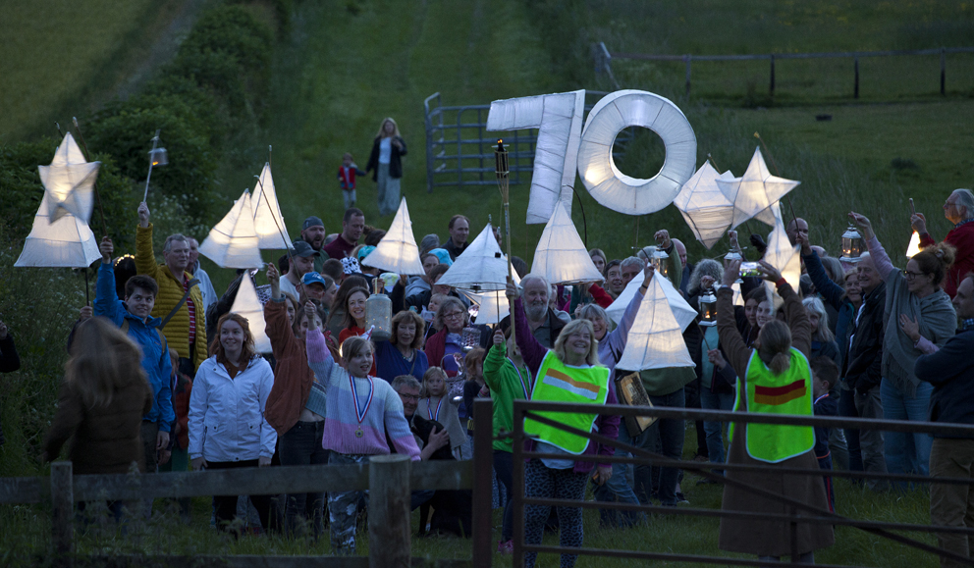
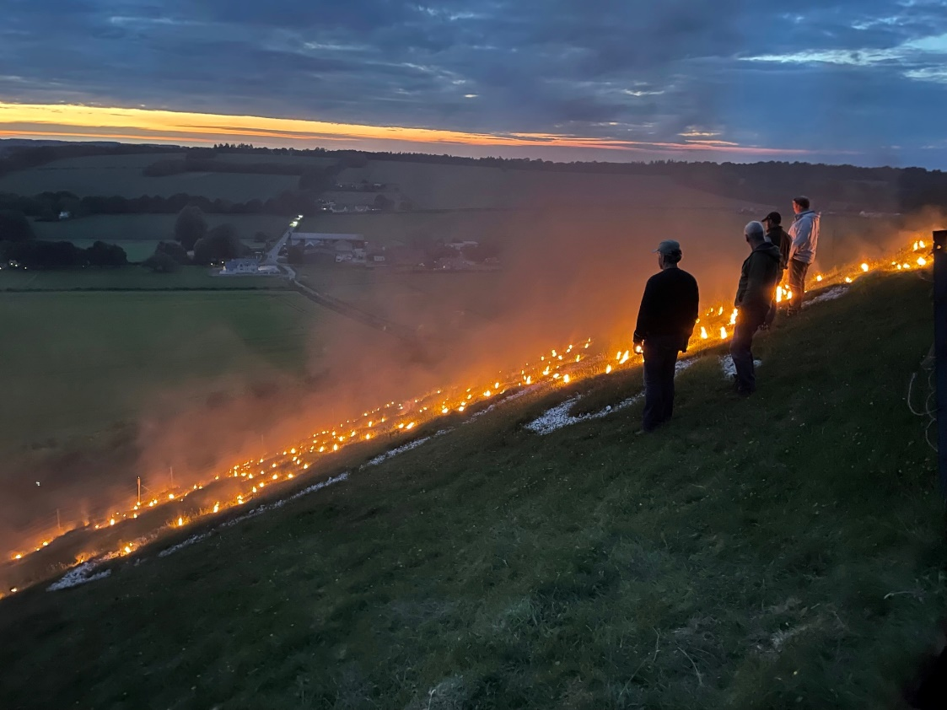
At 9.45 precisely, the team on the hillside started to light the flares along the bottom edge moving uphill and, like an opening flower, an elaborate crown slowly revealed itself and blossomed on the hillside above us in all its glory. With rounds of applause everyone agreed it was magnificent and held a fascination all of its own. We watched, mesmerised as Simon Barr’s drone moved above the flares, capturing extraordinary footage which can still be seen on the village website along with all other photos taken. www.fovantvillage.com Whilst other beacon flares could be seen in the distance there were none as unique as our Fovant contribution, which burnt on into the night. It was an incredible start to our Jubilee weekend.
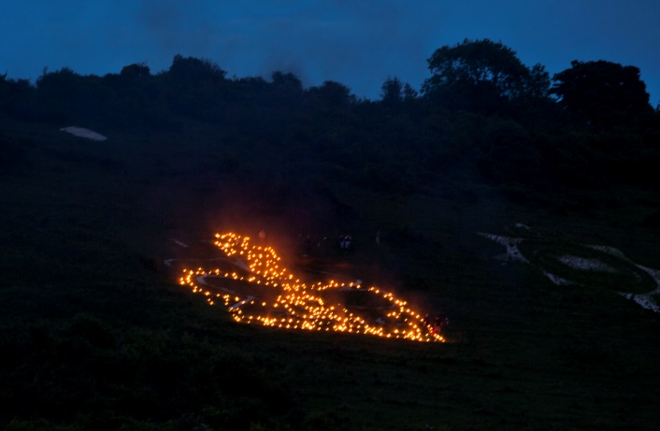
On the following day, South Today News featured the Beacon and, in the week following, ‘Wiltshire Life’ featured the Fovant Beacon, Lantern Procession and Jubilee Party in their August edition of the magazine.
Thanks to Susie Newman for giving up her time and leading the two Lantern making workshops in April & May, also to Julie Wallis for rounding up the children & being a ‘cleaning’ hero, Martin Wallis and Will Holmes for ensuring we were safe and for great parking, the Williams family for the use of their site, Chris Lock for taking some amazing photos, & lastly ‘Elaine and The Moons’ for providing refreshments.
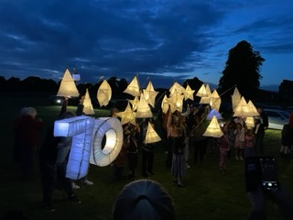

Friday June 3rd 2022 – Fovant Street Party
The Royal Platinum Jubilee bank holiday provided an opportunity to bring the people of the village together for a Street Party, which proved to be a wonderful, happy occasion for all. The simple act of closing a stretch of road gave the village the perfect location to come together and the photographs convey the amazing atmosphere created.
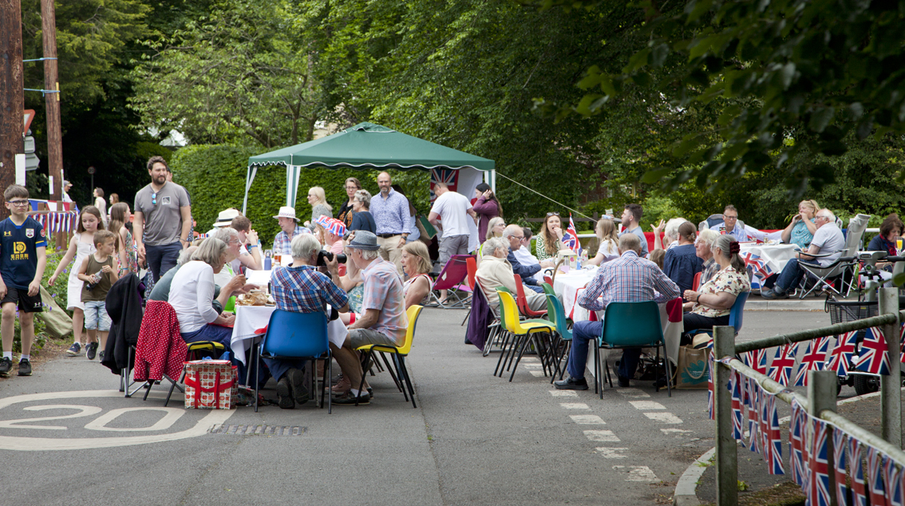
Diana Rae led on the co-ordination & organisation of the whole day ensuring everyone knew what was happening when, and who was doing what. The party started with the inaugural raising of the Union Flag outside the village hall by Tony Phillips , Chair of the Fovant Parish Council. This was the signal for the Cream Teas to be handed out, provided by FILGroup, and the live music to begin.
The main Tisbury Road from the Village Hall to Mill Lane was awash with bunting provided by Celia Haselgrove and perhaps it is no surprise that the Ice cream van was surrounded by the children’s dedicated play area, manned so capably by Julie Wallis & Chris Brantingham. At 4 o clock it seemed the whole village gathered in front of Orchard House ready for Mary Kirman, Keith McQuilton, & Jeremy & Derryn Hinks to set off the ducks! The duck race is an ever popular activity and the first race was won by the very aptly named duck, ‘Her Madge’ after Her Majesty. Soon it was time for a magnificent Tug of War for which we must thank Jordan Marchant and Russell Thompson and then the final part of the day – the clearing up and the removal of the traffic barriers by Martin Wallis and his team who had kept us so safe throughout the day. Diana said “It goes without saying that this was a community effort so thank you to every single person who contributed in any way, in the planning of the street party, the event itself and the clearing up afterwards.”
Just as important as the community’s days of celebration during the Jubilee, is the legacy for the village which received from grants from St George’s Church, The Surgery, the Parish Council and the National Lottery. There are many items & projects which were purchased for the day which will benefit the village in the long term. We were able to buy a union flag and pole to raise outside the Village Hall on specific dates such as Remembrance Day & a new iron bench to enhance the beauty of the village. There is now a tiled wall commemorating our village life permanently on display in the Youth Club, drawn and written by villagers and we shall soon have a pebble art installation outside the village hall. Some of the games purchased for the activity area and equipment for the Lantern workshops will stay with the Waterside Youth Club and the bunting produced can be used again on appropriate village occasions. The Youth Club & Village Hall both benefitted from stand up noticeboards and a commemorative tree will be planted this Spring.

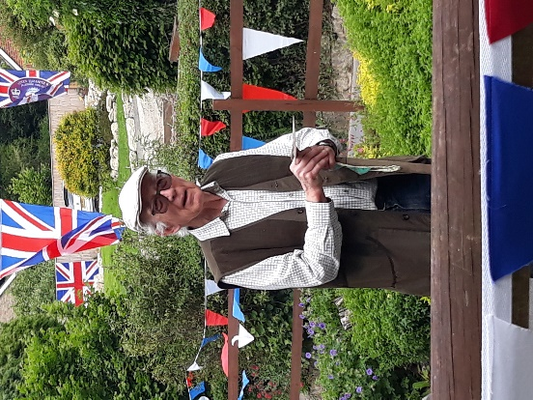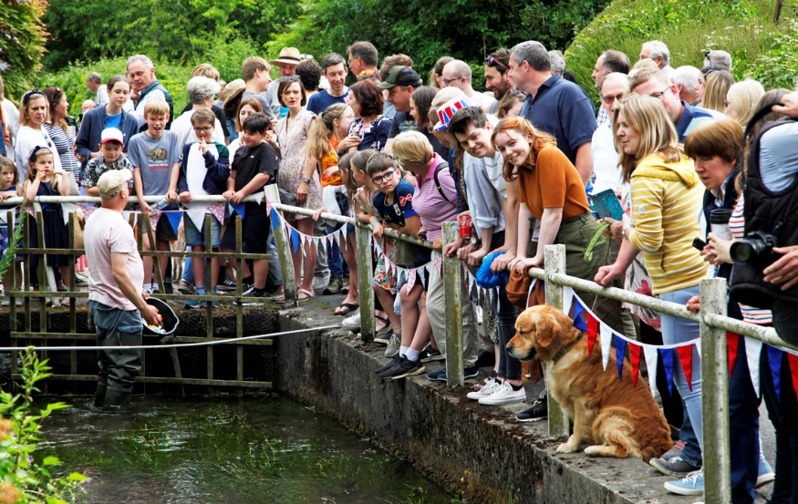

To everyone who contributed, to everyone in our village – well done and thank you – we came together as a community, had a magnificent time and created special memories.
Diana Rae, Leslie Brantingham & Derryn Hinks

22. FOVANT FETE. August 19th 2023
The village fete will, with the kind permission of the Williams family, take place in the afternoon of Saturday August 19th, on the field directly in front of East Farm Fovant.
The marquee will be erected Wednesday 16th, and removed on Tuesday 22nd, with the groundwork’s installed on Friday 18th.
The arena will be used for children’s games, tug of war,and dogs games, with the marquee hosting the FLG dispensing cream teas, with furnishings from the village hall, and cakes on a stall.
The other end of the marquee is planned for Fovant centric displays.
Other stalls, including hog roast, burgers, ice cream etc. will be available.
Pony rides will be given, and a number of MG cars will be on display, as well as other stalls and a raffle.
The primary task is to entertain everyone, but if enough money is raised to perpetuate the fete, a contribution will be made to the Stars Appeal.
Anyone who would like to lend a hand on the day or in its production should contact me on 07939411179.
Thank you,
William HOLMES
Fête Maker.

