Fovant Parish Council Playground And Playing field Risk Assessment

Description of Event
Nerf and Football event to be held at the Sutton Road Playing field on the 8th June 2025

Notes to Participants and Fovant Parish Council Contact Details
The Parish Council has conducted the Risk Assessment (below) and introduced control measures to mitigate the identified risks. The Council will ensure that all volunteers know the risks and understand the control measures before carrying out the activities by issuing a copy of this Risk Assessment.

However, no activity is completely without risk and all participants are reminded they have a responsibility for their own wellbeing and not to place themselves, or others, in harm’s way by taking unnecessary risks.

The contact details for the Council are as follows:

Name  Julie Wallis | Position  Parish Clerk | Contact Details  Tel: 07816511340

Method of Scoring Risk Assessments

The following shows how the risk of each hazard is scored.

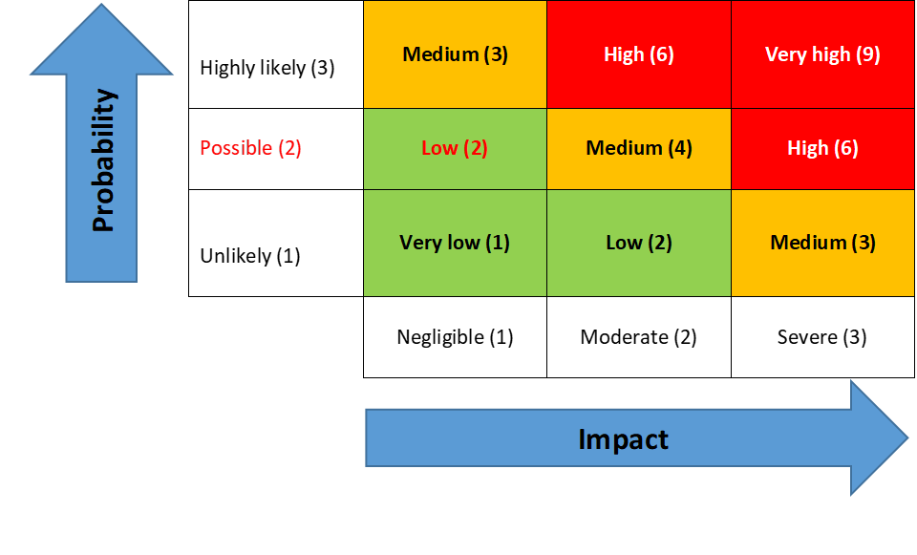 | The Council’s Risk Management Policy is on the website -  Councillors are to review the ‘Controls in Place’ to ensure they exist, they relate to and mitigate the Risk Identified  Risk Factor Impact Action  Red High/very high Immediate notification to the chair and vice chair Identify remedial action for implementation  Amber Medium Immediate notification to the chair and vice chair.  Green Low Notify chair and vice chair

REF | Activity | Risk/Hazard Description | Who is at risk / Risk  Category | Risk Score |  |  |  | EXISTING CONTROLS | FURTHER ACTIONS | RISK OWNER | REVIEW DATES
 |  |  |  | Impact | Likelihood | Risk Rating | Red /  Amber/ Green | Key points | if required Key points |  | LAST | NEXT
PG01 | Monthly playground inspections to take place by Fovant Parish Council | Ensure safety of equipment on a monthly basis | Young people | 1 | 1 | 2 | GREEN | - Clerk/responsible councillor to undertake monthly checks on existing play equipment for early identification of risk issues | Audit form devised and checks Commenced | CLERK | 05/25 | 06/25
PG02 | Yearly ROSPA inspection to take place | Annual professional review of play equipment | Young people | 1 | 1 | 2 | GREEN | - Clerk to book annual ROSPA inspection | Clerk to contact ROSPA | CLERK | 10/24 | 10/25
PG 03 | Gate does not Shut or lock | Unauthorised entry by dogs/others | Young people | 2 | 2 | 4 | AMBER | - Clerk to seek professional solution/replace gate |  | CLERK | 05/25 | 05/25
PG 04 | Seating areas overgrown by vegetation | Risk to those wishing to sit | Young people | 4 | 2 | 6 | AMBER | - Clerk to arrange with grass contractor to cut back vegetation as soon as possible. | COMPLETE | CLERK | 05/25 | 06/25
PG 05 | See saw | Potential for injury as equipment goes to floor and is rusted | Young people | 4 | 2 | 4 | RED | - See saw taken out of action with immediate effect.  - Seesaw rendered out of action by way of taping and clear signage showing it is not to be used.  - Contact manufacturer to ascertain if a repair can be sought.  - If unable to repair arrange for removal. | COMPLETE  COMPLETE  COMPLETE | CLERK | 05/25 | 06/25
PG 06 | Seated roundabout | Sited in 1993 is old and unmaintainable | Young people | 6 | 2 | 8 | AMBER | - Whilst still in working order to remain in operation.  - Contact manufacturer to ascertain if they will be able maintain it to a good standard. | Awaiting manufacturer | CLERK | 05/25 | 06/25
PG 07 | Spring based seated equipment | Sited in 2002 is old and unmaintainable | Young people | 2 | 2 | 4 | AMBER | - Whilst still in working order to remain in operation.  - Contact manufacturer to ascertain if they will be able maintain it to a good standard. | Awaiting manufacturer | CLERK | 05/25 | 06/25
PG08 | Flooring overgrown with weeds | May not give a suitable surface to protect children | Young people | 2 | 2 | 4 | AMBER | - Clerk to arrange with grass contractor to spray the overgrowth of vegetation as soon as possible, but after the school holidays. | COMPLETE | CLERK | 05/25 | 06/25
PG09 | Playing field goal posts | Loose and may post a risk to falling | Young people | 1 | 1 | 2 | GREEN | - Clerk to contact a local contractor to get quotes to re-cement the posts back to a stable position. | COMPLETE | CLERK | 05/25 | 07/25
PG10 | Fence to playing field | Two posts loose and not supporting the fence | General public | 1 | 1 | 2 | GREEN | - Clerk to contact local contractor to install posts to stabilise the fence. | COMPLETE | CLERK | 05/25 | 07/25
PG11 | Playfield opening | Children may run onto the road | Young people | 1 | 1 | 2 | GREEN | - Clerk to source a suitable gate and have fitted by competent installer | COMPLETE | CLERK | 06/25 | 07/25

