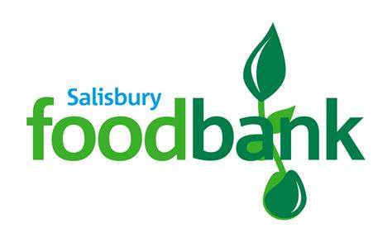

Fovant Satellite food bank

Fovant Free Church, The Chapel, High Street, Fovant, SP3 5JL
Every Thursday 1:30 to 3:30 from 1st December 2022.
Open for tea/coffee, a listening ear and a warm discreet space as well as accepting food bank vouchers
You can register for food bank vouchers at Fovant Surgery please speak to reception on 01722714789 or visit the surgery.
For further information on the food bank facilities please contact Julie Wallis on 07816511340

*Food bank donations continue in the box outside “Ashbrook” near the village hall but donation of personal care items and domestic pet foods will be gratefully accepted at the food bank in the Chapel when open, or by calling Julie on 07816511340.

