Fovant Parish Council Young Peoples Event Risk Assessment

Description of Event
Spooky trail event to be held on the 31st October 2025 in Fovant Village.

Notes to Participants and Fovant Parish Council Contact Details
The Parish Council has conducted the Risk Assessment (below) and introduced control measures to mitigate the identified risks. The Council will ensure that all volunteers know the risks and understand the control measures before carrying out the activities by issuing a copy of this Risk Assessment.

However, no activity is completely without risk and all participants are reminded they have a responsibility for their own wellbeing and not to place themselves, or others, in harm’s way by taking unnecessary risks.

The contact details for the Council are as follows:

Name  Julie Wallis | Position  Parish Clerk | Contact Details  Tel: 07816511340

Method of Scoring Risk Assessments

The following shows how the risk of each hazard is scored.

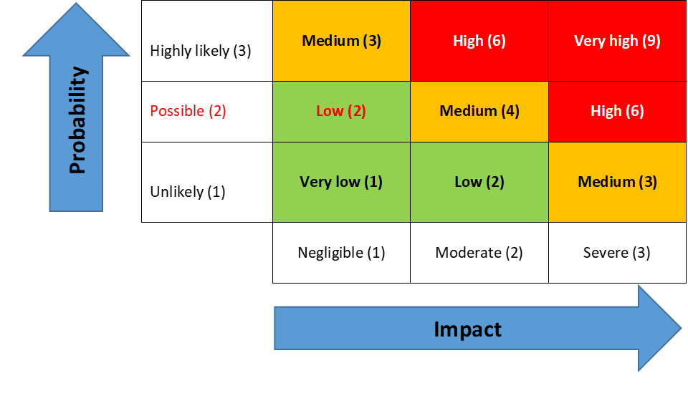 | The Council’s Risk Management Policy is on the website -  Councillors are to review the ‘Controls in Place’ to ensure they exist, they relate to and mitigate the Risk Identified
  Risk Factor | Impact | Action
  Red | High/very high | Immediate notification to the chair and vice chair  Identify remedial action for implementation
  Amber | Medium | Immediate notification to the chair and vice chair.
  Green | Low | Notify chair and vice chair

REF | Activity | Risk/Hazard Description | Who is at risk / Risk  Category | Risk Score |  |  |  | EXISTING CONTROLS | FURTHER ACTIONS | RISK OWNER | REVIEW DATES
 |  |  |  | Impact | Likelihood | Risk Rating | Red /  Amber/ Green | Key points | if required Key points |  | LAST | NEXT
Spooky 01 | A proportionate level of volunteers have an enhanced  DBS check. | Insufficient level of DBS checked volunteers | Young people | 1 | 1 | 2 | GREEN | - Parents will be expected to stay with their children for the duration of the event.  - Event will have at least six persons acting as marshalls Two of each team will have an DBS check. Any marshall without a DBS will not volunteer alone and will always be in the company of a volunteer with an enhanced DBS. | Completed | Marshalls | 30/10
spooky02 | Registration of young people. | Consent from person with parental responsibility | Young people | 2 | 2 | 4 | AMBER | - All attendees must have a signed consent form allowing participation in the event from the person with their parental consent. |  | Karen Lineker | 30/10
EVE 03 | Control of registration of young people. | Risk of unauthorized young people participating | Young people | 2 | 2 | 4 | AMBER | - Attendees must have completed registration forms from parents before participating in the event. |  | Karen Lineker | 30/10
EVE 04 | Potential risk to health due to unknown medical conditions. | Unknown health issues | Young people | 4 | 2 | 6 | AMBER | - Attendees must have completed registration forms giving medical details from parents before participating in the event. |  | Karen Lineker | 30/10
EVE 05 | Risk of a road safety event | Potential for injury | Young people | 4 | 2 | 4 | AMBER | - Village event signs to be positioned at key intersections alerting vehicular users of an event.  - Parents will be accompanying their children on the event.  - The event will be in two teams with three volunteers for each team, one volunteer taken pole position and one volunteer and the rear and third roving with the team keeping children safe.  - All volunteers will have torches to alert traffic of persons potentially in the road. |  | ALL | 30/10
EVE 06 | Weather | Adverse weather conditions | All | 2 | 2 | 4 | AMBER | - Potential to cancel in the event of a poor weather. |  | All | 30/10
EVE 07 | Cancel the event | Insufficient numbers | All | 2 | 2 | 4 | GREEN | - Organisers to assess at 10 days before event  - Event closed at 30 children. | Completed | Julie Wallis/Karen Lineaker | 30/10

