Fovant Parish Council Speed Indicator Device (SID) Risk Assessment

Description of Planned Work
The installation of the Speed Indicator Device (SID) within approved 20mph and 30mph zones by a minimum of two people (Councillors, staff or volunteers).

Notes to Participants and Fovant Parish Council Contact Details
The Parish Council has conducted the Risk Assessment (below) and introduced control measures to mitigate the identified risks. The Council will ensure that all volunteers know the risks and understand the control measures before carrying out the activities by issuing a copy of this Risk Assessment, and all participants will be required to complete the Wiltshire Council SID Safety Awareness Training.

However, no activity is completely without risk and all participants are reminded they have a responsibility for their own wellbeing and not to place themselves, or others, in harm’s way by taking unnecessary risks.

The contact details for the Council are as follows:

Name  Julie Wallis | Position  Parish Clerk | Contact Details  Tel: 07816511340

Method of Scoring Risk Assessments

The following shows how the risk of each hazard is scored.

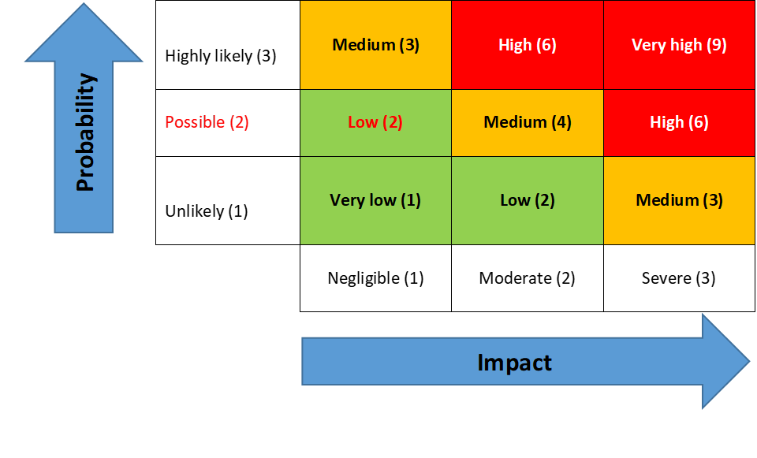 | The Council’s Risk Management Policy is on the website -  Councillors are to review the ‘Controls in Place’ to ensure they exist, they relate to and mitigate the Risk Identified  Risk Factor Impact Action  Red High/very high Immediate notification to the chair and vice chair Identify remedial action for implementation  Amber Medium Immediate notification to the chair and vice chair.  Green Low Notify chair and vice chair

REF | Activity | Risk/Hazard Description | Who is at risk / Risk  Category | Risk Score |  |  |  | EXISTING CONTROLS | FURTHER ACTIONS | RISK OWNER | REVIEW DATES
 |  |  |  | Impact | Likelihood | Risk Rating | Red /  Amber/ Green | Key points | if required Key points |  | LAST | NEXT
SID 01 | Equipment located in an unsuitable location | Equipment, vehicles or members of the public are endangered | SID Team | 2 | 2 | 4 | AMBER | - All sites used are agreed in advance with Wiltshire Council Highways  - All new sites must be agreed with Wiltshire Council Highways |  | Clerk
SID 02 | Working adjacent to the Highway | Collision with moving traffic | SID Team  Public | 2 | 3 | 6 | RED | - Stay off the highway and remain on the driveway or pavement as far as is possible  - Wear high-vis vests  - Allocate someone to monitor traffic movements and be aware of the road speed  - Users must not attempt to stop or direct traffic.  - Carry out work between 10am – 2pm to avoid peak traffic |  | SID Team
SID 03 | Parking space for volunteer vehicle | Risk of collision between vehicles, volunteers or pedestrians and risk of obstruction | SID Team  Public | 2 | 2 | 4 | AMBER | - Users to identify a safe place to park their vehicle which does not cause an obstruction and allows them to enter and exit their vehicles safely |  | SID Team
SID 04 | Threat from aggressive people | Assault by member of public / driver | SID Team | 2 | 2 | 4 | AMBER | - Users to cease SID activities if they encounter anyone causing them to feel threatened  - Any threats of violence (whether or not actual injury /damage occurred) should be reported to the Police and the Parish Clerk should be made aware |  | SID Team
SID 05 | Slips, Trips and Falls | Injury such as sprained ankle from tripping or falling | SID Team | 2 | 2 | 4 | AMBER | - Users to wear strong, sensible footwear with adequate grip – no open-toed footwear allowed  - SID site should be cleared of any obstructions |  | SID Team
SID 06 | Manual handling e.g. lifting and/or holding the SID or battery pack | Back injury or other injuries associated with incorrect lifting and handling | SID Team | 2 | 2 | 4 | AMBER | - Users to follow the installation guidance issued and in line with manufacturer’s instructions.  - Battery packs MUST be removed before lifting the SID.  - Users with back problems should assess whether they can safely lift the SID and battery packs  - All staff and volunteers to follow the recommended manual handling guidelines set out by Health & Safety Executive. Full information can be found at http://www.hse.gov.uk/toolbox/manual.htm |  | SID Team
SID 07 | Working at height | Risk of personal injury from falling | SID Team | 2 | 2 | 4 | AMBER | - If step ladders are used they are assessed as fit for purpose  - Step ladders are not to be placed against the pole  - Users are familiar with HSE guidance “Working at Height Safely”  https://www.hse.gov.uk/pubns/indg401.pdf  - Users to follow HSE guidance “Safe use of ladders and step ladders”  https://www.hse.gov.uk/work-at-height/ladders/ |  | SID Team
SID 08 | Use of damaged equipment or faulty electrical source | Electric shock | SID Team | 2 | 2 | 4 | AMBER | - Users to carry out an inspection of the SID to ensure it is not damaged before installation  - Charging of batteries must be completed using a trusted electrical source |  | SID Team
SID 09 | Weather | Adverse weather conditions causing slips, falls, over heating etc | SID Team | 2 | 2 | 4 | AMBER | - Postpone SID activities in cases of extreme weather conditions |  | SID Team

